Simple Linear Regression Using Excel
Presented by the QSC

Simple linear regression is used to show linear relationships between two quantitative/numeric variables – an independent (x) variable and a dependent (y) variable.

As the x variables increases or decreases, the y variable increases or decreases. The y variable is dependent on the x variable.

Part 1: Installing Data Analysis ToolPack

Step 1: Click the File Tab on the top left
Step 2: Click Options on the bottom left
Step 3: Click Add-Ins
Step 4: Select Analysis ToolPak and click GO

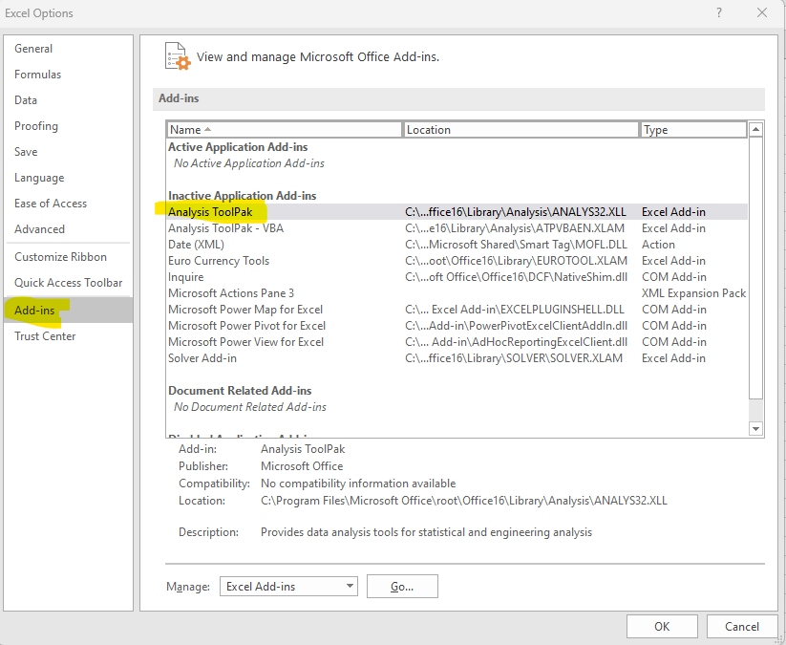

Step 5: Check Analysis ToolPak and select OK. The ToolPak will now be available under the Data tab.

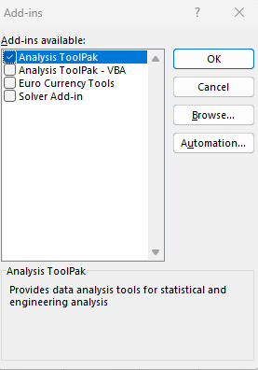

Part 2: Understanding the Data

- What is the independent (x) variable: __________________________

- What is the dependent (y) variable: ____________________________

- Run descriptive statistics for both variables. Fill out the table below:
Statistic | Temperature | Ice Cream Profits
Mean
Median
Minimum
Maximum
Count (sample size)

Part 3: Graphing the Data

- Hypothesize what you expect the relationship to be.

- Create a scatterplot of the data
  - Create a Title
  - Label the axes
  - Add the trendline
  - Add the regression equation and r-squared

- Was your hypothesis correct?

Part 4: Regression

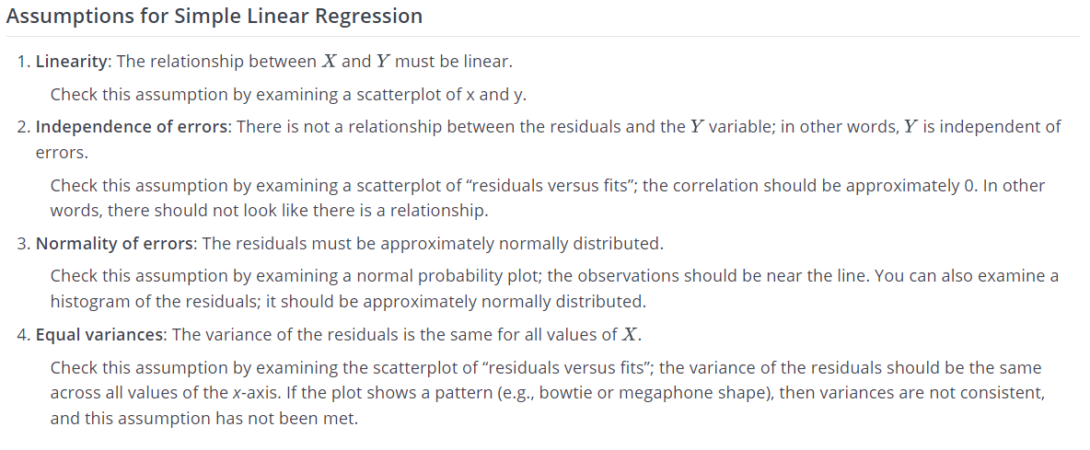
Source: https://online.stat.psu.edu/stat500/lesson/9/9.2/9.2.3

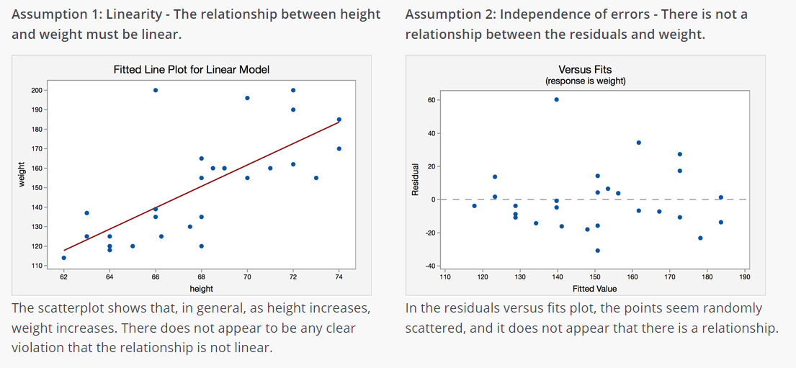
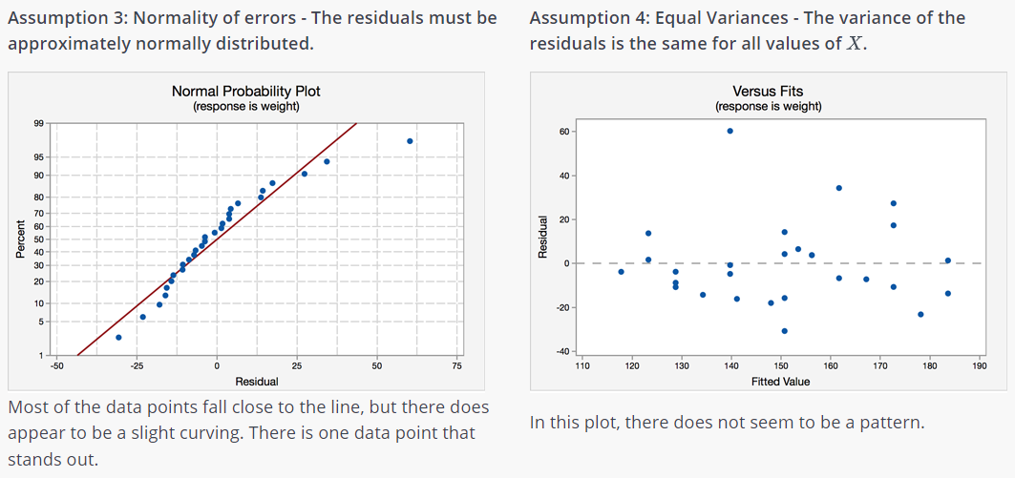

  - Run a linear regression equation.
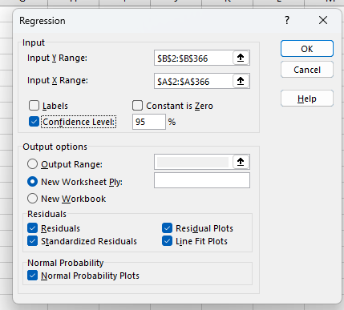
  - What is the correlation coefficient?

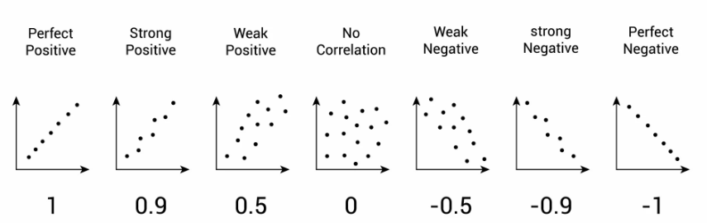

  - What is the coefficient of determination?

R^2 meaning: ______ % of the variability in y is explained by x

  - Test if linear regression is an appropriate model for your data.

  - Report the regression equation. Predict the ice cream sales when the temperature is 65 degrees.

